**LINQ**

Language-Integrated Query (LINQ) is a powerful set of technologies based on the integration of query capabilities directly into the C# language. LINQ Queries are the first-class language construct in C# .NET, just like classes, methods, events.

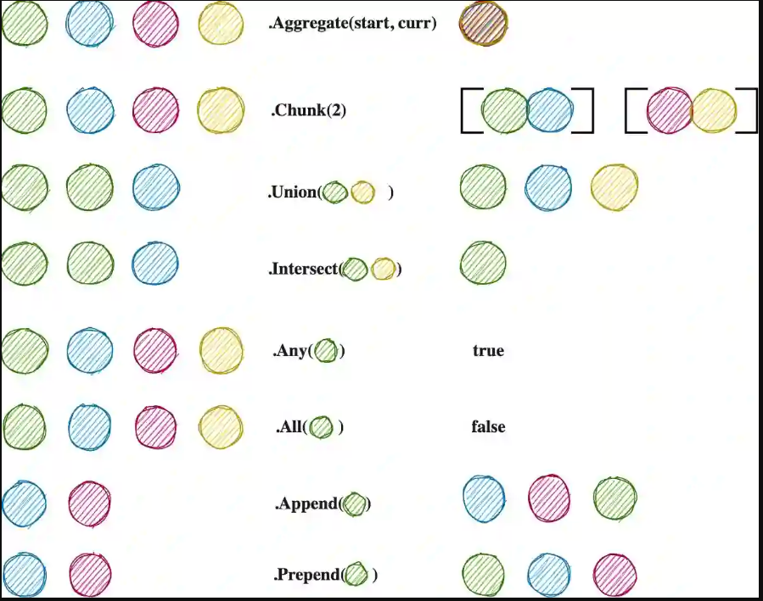

**WHY LINQ ?**

We should take a look at the project to understand better.